Why Secession and Why Now? :
The Political Economy of Catalonia’s Push to Exit Spain
________________________
Julia Steffen
University of Notre Dame
Spring 2016

Advised by:
Eva Dziadula
Assistant Professor, Department of Economics

Eric Sims
Associate Professor, Department of Economics

Ben Heller
Associate Professor of Spanish, Department of Romance Languages and Literatures

Leonardo Francalanci
Visiting Assistant Professor of Catalan, Department of Romance Languages and Literatures

Abstract: This study examines the mounting support for Catalonia’s secession from Spain from the perspective of the political economy of secession. According to this theory, regions favor secession when there is a perceived disparity between current economic performance and optimal economic performance that is attributed to state fiscal structures. Using public opinion survey data from the Baròmetre d'Opinió Política, this study utilizes OLS regression to determine the effect of two main explanatory variables—desire that Catalonia assume responsibility for taxation and spending policy and perceiving Catalonia’s economic situation to be superior to Spain’s—on two dependent variables: independence as the preferred level of Catalonian autonomy and pro-independence voting in a referendum. The empirical results suggest that desire for Catalonia to assume fiscal policymaking control and perceiving the Catalonian economy as stronger are significant factors driving secessionist sentiment. These results imply that the current status quo is not working in Spain, and that national unity is contingent on Spain conceding to some of Catalonia’s demands.

Table of Contents

- Introduction………………………………………………………………………………..3
- Catalonia’s Nationalist Movement………………………………………………………..5
- Theoretical Framework: The Political Economy of Secession……………………………7
- Precedent for Secession: Global and European Bids…………………………………….10
- Why Secession and Why now? The Case of Catalonia………………………………….12
- Data………………………………………………………………………………………15
- Estimation Strategy………………………………………………………………………22
- Results and Discussion…………………………………………………………………..23
- Conclusion—Implications: Breakup or Unity Scenarios………………………………...26
- Bibliography……………………………………………………………………………..29

I. Introduction
Catalonia’s struggle for fiscal autonomy and independence is an old fight in new times that is reaching its crisis point. Catalonia, a small territory between the Pyrenees and the sea with its capital in Barcelona, was founded in the late ninth century and has undergone a contentious history of gained and lost autonomy. Historically, the ‘Catalanism’ movement has been structured around the defense of the region’s linguistic and cultural identity—the right to teach its own language (Catalan) and observe its own traditions. Recently, however, the movement diverged from talk about autonomy and regionalism and called for outright independence from the Spanish State thereby challenging Spain’s Constitution (1978).
On Catalan National Day, 11 September 2012, 1.5 million people gathered in Barcelona to declare their shared desire for secession making it the biggest pro-independence demonstration in Catalonia in democratic Spain (Boylan 2015). In December 2012, nationalist coalition party CiU (Convergència i Unió) and separatist ERC (Esquerra Republicana de Catalunya) announced that they would arrange a referendum on independence in 2014. The estimated turnout was around 40 percent, and the results were overwhelmingly pro-independence with 80.8% of votes cast in favor of an independent state of Catalonia. Artur Mas, president of the Generalitat de Catalunya, announced in January 2015 that his intention was for 2015 election vote to be turned into an alternative vote on the independence of Catalonia given the inability of Catalonia to hold a legal referendum on the issue.
Why do Catalans desire independence and why now? This study utilizes a theoretical framework based on the literature on the political economy of secession to analyze favorability towards Catalonia’s separatist movement. According to this theory, regions favor secession when there is a perceived disparity between current economic performance and optimal economic performance that is attributed to state fiscal structures. Catalonia, lacking fiscal policymaking control, forfeits a huge portion of its tax revenue to the State and gets little back leading to feelings of being shortchanged and used. The goal of this study is to reframe what has been historically viewed as an ethnic dispute, as a culmination of fiscal grievances. The hypothesis is that the driving force behind Catalonia’s secessionist movement is a desire for Catalonia to assume responsibility for taxation and spending policy.
To test the hypothesis, this study analyzes public opinion data from the Baròmetre d'Opinió Política [Political Opinion Barometer] (BOP), a survey administered by the Centre d’Estudis d’Opinió (CEO) of the Generalitat de Catalunya. Examination of responses can shed light on the relationship between opinions on fiscal policy and secessionist sentiment. Whereas other studies have utilized cross-regional data to evaluate linkage between wealth and separatism, this study uniquely looks at personal opinion data over the last decade to unveil the individual-level preferences and perceptions that motivate pro- or anti- secessionist support. Summarily, I find that desire for Catalonia assuming fiscal policy control has a significant bearing on increasing both desire for independence and voting for independence in a referendum.
This study will first briefly trace Catalonia’s nationalist movement on the social and political stage to contextualize the modern movement. Secondly, it will broach into a broader discussion of the political economy perspective on secessionist movements before, thirdly, contextualizing why Catalonia desires independence given the presented framework. Fourth, it explains the datasets and methodology used. Finally, it presents and discusses the results of the empirical models and their implications for the future of Spain.

II. Catalonia’s Nationalist Movement
During the thirteenth century, Barcelona was the administrative base of the Crown of Aragon, a powerful military and commercial empire, having fiscal autonomy independent of the king setting the precedent for Catalonia’s desire for fiscal autonomy. When Castile and Aragon unified through marriage in 1479, political and military power was centered on Castile while economic power was located on the periphery—the Basque Country and Catalonia (Castells 2014). Catalonia, however, continued to make bids for independence and was briefly reestablished as the Catalan Republic in 1640 under the protection of France, foreshadowing another short bout of independence under Napoleon from 1810-1812.
The War of Spanish Succession (1701-1714), prompted by the heirless Spanish king dying, put Catalonia’s future into contention. The international war ended with the victory of the Bourbon Philip V despite strong Catalan opposition. The consequential repression of the Catalan people was aggressive; the Catalan State and Crown of Aragon were abolished and ruled under the Castilian absolutist law. The death of the Crown of Aragon was the birth of the modern unitary Spanish State. Despite adversity, Catalonia emerged as an economic powerhouse and industrial leader, and the ‘Catalanism’ movement materialized. Early twentieth century, Catalonia regained its united administrative system and some level of self-rule, but Spanish dictator Primo de Rivera curtailed this independence in 1925.
In 1931, an autonomous government for Catalonia was established under the name of Generalitat. However, this was put in disputation due to the Spanish Civil War (1936-1939) that resulted in thousands of casualties, including the death of more than 50,000 Catalans. Following the Republican defeat to General Francisco Franco’s forces, hundreds of thousands of Catalans were forced into exile and the President of the Catalan Government was executed by firing squad. El Caudillo (The Leader) began a reign of terror: political opponents were persecuted, democratic rights were abolished, media was censored, and lingual and cultural regionalism was repressed. The Catalan language and symbols were forbidden in all public spaces, schools, and books, and Catalonia’s Statute of Autonomy and Generalitat were disbanded. General Francisco Franco’s death in 1975 ended a four-decade long dictatorship, and hailed in a new era of democracy under King Juan Carlos I. This changed the political landscape considerably.
The Generalitat of Catalonia was restored in 1977, and in 1979 Catalans approved their second Statute of Autonomy establishing the Autonomous Community of Catalonia, its current legal status. The country’s political system is the result of the clash of remnant centralist tendencies from the Franco regime and recognition that Spain is an assembly of distinct regions deserving of certain competences (Boylan 2015). Democratization was a tug-of-war between those advocating for minimal decentralization and those arguing for a federal-type system. As a great compromise, the Constitution created seventeen autonomous communities thereby recognizing the presence of and affording rights to regions in Spain, while maintaining that Spain is an unbreakable unit.
For more than twenty years, the CiU (Convergència i Unió), a center-right Catalan nationalist coalition party of the CDC (Convergència Democràtica de Catalunya) and UDC (Unió Democràtica de Catalunya), dominated elections on a platform promising to negotiate the best deal for Catalonia, short of secession, with the central government in Madrid. After losing to leftist parties in 2003 and 2006, CiU regained power in the 2010 elections but lacked an overall majority needing a coalition partner. CiU’s reemergence occurred in the context of the global economic crisis of 2008-09 and the Spanish Constitutional Court’s decision in 2010 to declare parts of Catalonia’s 2006 Statute of Autonomy unconstitutional. In December 2012, nationalist coalition party CiU (Convergència i Unió) and separatist ERC (Esquerra Republicana de Catalunya) announced that they would arrange a referendum on independence in 2014. While known as the Catalan independence referendum, it was rebranded the “citizen participation process on the political future of Catalonia” after the Constitutional Court of Spain suspended the original vote. The ballot gave two questions: “Do you want Catalonia to become a State? (yes/no)” and if the answer is in the affirmative, “Do you want this State to be independent? (yes/no)”. The estimated turnout was around 40 percent, and the results were overwhelmingly pro-independence with 80.8% of votes for Yes-Yes, 10.1% Yes-No, and 4.5% No.
President Artur Mas announced in January 2015 that his intention was for 2015 election vote to be turned into an alternative vote on the independence of Catalonia given the inability of Catalonia to hold a legal referendum on the issue. June 2015 marked the dissolution of the CiU coalition due to fragmentation in separatist ideology. For the Catalan parliamentary election of 2015, five parties ran together—including the CDC—under an ideology of Catalan independence in a coalition called Junts pel Sí, while the UDC ran independently. Junts pel Sí won the majority of parliamentary seats with 62 seats and 39.6% majority of the votes.
III. Theoretical Framework: The Political Economy of Secession
This study adopts a theoretical framework based on literature on the political economy of secession to examine the ongoing separatist movement of the autonomous region of Catalonia of Spain. According to this theory, regions operate based on a wealth maximization calculation; they secede, merge, or maintain the status quo based on the existence, or perceived existence, of a disparity between their current economic performance and optimal economic performance. Separatism becomes preferred when there is centralized economic policy making, but there are strong regional differences in economic performance. An economically advantaged region, such as Catalonia, pushes for secession to put an end to subsidizing disadvantaged regions in the country. Conversely, poorer regions favor secession as a means of ending competition with richer regions over public goods and employment opportunities. In sum, one-size-fits-all policymaking leads to political unrest as regions recognize that they might be better off on their own than in the standing political system that does not appear to address or meet their specific needs.
Spain consists of seventeen autonomous communities whose structures are determined both by the devolution allowed by the constitution and the stipulations of their respective Statutes of Autonomy. Financing is a major contention between the communities and the central government, particularly control over revenue supply. While the communities have generous spending liberties, the central government in Madrid still levies and collects most taxes creating a vertical fiscal imbalance. The revenue is then redistributed across fifteen of the seventeen regions—the Basque Country and Navarre have fiscal autonomy and are excluded—according to a policy of fiscal equalization. In this system, rich regions become net contributors to the system and poorer communities become net recipients causing friction. The system only works if the central government walks a tax-and-transfer-scheme tightrope: keeping regions rich enough to stave off secessionist sentiment but making sure regions are only slightly more prosperous than if independent.
Dissatisfaction with the national political environment can have a profound effect on a Catalonians’ desire to vote in favor of secession. Secession is usually an option of last resort, an alternative considered only when all other options working within the current system have been eliminated. Given that in reviewing Catalonia’s proposed new Statute of Autonomy in 2006, the Spanish Constitutional Court identified parts as being unconstitutional, Catalonians may feel that they have reached an impasse in negotiation with the central government. All attempts to work within the system have been disregarded and derogated; political change is the perceived solution to economic decline. Furthermore, economic and political strains heightened following the global financial crisis of 2008-09, when the Spanish housing bubble burst and unemployment reached record highs. Already present disparities in economic performance across regions widened. This put a greater strain on advantaged regions that had to pick up the slack of increasingly disadvantaged regions while being unable to raise their own taxes resulting from horizontal fiscal imbalance.
Differences in culture, ethnic identity, and language are further motivations prompting secessionist sentiment. While increasing nationalism in their own right, these factors also serve as a lens through which to contextualize fiscal relationships. A region’s separatism is strongest when the region has a unique ethnic character and is economically fitter than the country as a whole—Catalonia is a case in point (Boylan 2015). Catalonia is a great case study for the theory of the political economy of secession, and for a parallel discussion of the broader European question of monetary union without fiscal union that is at center-stage in the Eurozone/EU Greece versus Germany battle of wills. There are potential problems to be had when centralized economic policymaking is enforced across highly decentralized economies. Given Catalonia’s unique combination of distinct cultural and linguistic identity and fiscal grievances, it provides the perfect context to test for economic motivations for secession while controlling for ethnic differences. By no means is Catalonia an isolated case of secessionist fervor, Quebec and Scotland are only two additional contemporary examples of relatively small territorial regions fighting for autonomy. The current trend of “internal exits”, as secession is sometimes termed, makes empirical research into the causes provoking separation especially relevant and interesting.
The conceptual framework of a political economy predicts that: 1) The greater the perceived prosperity of Catalonia relative to the rest of Spain, the stronger the support for secession, and 2) The stronger the support for the Catalan government to assume fiscal policymaking control, the greater the support for secession.
IV. Precedent for Secession: Global and European Bids
Boylan’s (2015) hypothesis that the driving force behind Catalonia’s secessionist movement is a desire for Catalonia to assume responsibility for taxation and spending policy is the framework this study is built upon. The political economy of secession is a relatively new area of study, and the literature on Catalonia, and public opinion data in particular, is limited. Boylan’s study covering public opinion data from 2011 through 2013 found that stronger support for Catalonia to assume fiscal policy is positively and significantly associated with higher levels of preferred Catalan self-governance and independence plus greater likelihood to vote for independence. This study will expand on this research by examining support for Catalan independence for a longer time period including before the global financial crisis, and additionally testing the significance of perceived relative economic conditions while controlling for real economic indicators.
Catalonia, by no means, is the first region in recent history to put in a bid for independence. The key determinants of secession, at a regional level, within democracies are: having a regional language, having a recent history of independence, having a relatively high income, having a large population size, and having more multipartism (Sorens 2005). The importance of relative affluence was a particularly strong result. Catalonia fits many of these qualifications: it has its own language of Catalan, has a history of past independence, is economically advantaged, accounts for a significant portion of Spanish population, and has strong Catalan nationalist parties.
Sambanis and Milanovic (2014) contribute to the literature, arguing that self-determination demand is moderated by the anticipated economic costs of policy autonomy. Based on an analysis of 876 regions in decentralized systems worldwide specifically looking at relative income and regional inequality (proxies for feasibility of autonomy demands), the authors found that richer, more populous, and resource-endowed regions are more likely to enjoy higher degrees of autonomy. These regions are in a better power position since they can make more credible threats of “exit” to demand more policymaking liberty from the center because they can afford the cost of supplying public goods to their populace. Furthermore, inequality in more ethnically distinct regions is tied to higher observed levels of independence. While Catalonia has a better bargaining position, the lack of a proper answer from Spain’s largest political parties to its revisions of its current Statute of Autonomy is probably the main reason why currently many Catalans are asking for independence.
While, just two years ago in 2014, Scotland was able to legally hold an independence referendum with the blessing of the United Kingdom, Spain is being rebuffed at every turn. This tension is exacerbated by the fact that despite the two bids for independence appearing superficially similar—small territories with prior history of independence—the similarities end quickly. In direct contrast to Catalonia, ethnic, cultural, religious, and language differences are not factors in the case for Scottish secession. The economy and employment seem to be the main motivators, though, when compared to Wales, Northern Ireland, and the regions of England, Scotland is average in relation to indicators such as income and unemployment (Bell 2014). Spain, on all accounts, has a stronger case for independence but is given lesser credibility.
V. Why secession and why now? The Case of Catalonia
The economics of secession is still a theory in its beginning stage, and much of the discussion focuses on the opportunity cost of heterogeneity versus the benefit of size with the international openness of the economy and the quality of democracy and institutions being deciding factors (Castells, 2014). Economic globalization in many large European countries has been followed up by political devolution. There are indications, however, that the decentralization of Spain has been asymmetric. The breakdown of Catalonia and Spain’s relationship stability in recent years climaxed in late 2015 as Spain’s government stalled with no clear majority in parliamentary elections—largely due to political unrest in Catalonia.
The deterioration of this relationship is principally due to the limited ‘real political decision-making power’ afforded to regional governments. According to Castells (2014), the quality of decentralization, measured by the strength of a country’s stability and the reduction of incentives to secede, is highest when regional governments have an ability to represent heterogeneous preferences and when the national framework ensures conflict resolution through cooperation and compromise. This builds a sense of political community—a feeling of belonging across different groups of people living in a country. Sánchez (2010) concurs, stating that ‘social capital’—the networks of relationships among people who live and work in a particular society that enables the society to function effectively—is a major productive factor affecting economic growth, efficiency, and productivity. Culture and as an extension (or proxy) trust, in this sense, is one of the key determinants of regional wealth in Spain. A society that expresses trust in people and institutions, based on shared responsibility, will be more economically prosperous (Sánchez 2010). As such, improvement in confidence and social networks in Spain may have led to significantly higher growth rate of GDP due to a reduction of transaction costs. However, increased regionalism, in some cases, is at the cost of nationalism. A sense of political community does not currently hold to be true for many Catalans; many feel that they are Catalans living in Catalonia versus Spaniards living in Catalonia or Catalans living in Spain. The strong ethnic pride present in Catalonia is accounted for in my models through a variable measuring respondents self-reported level of Catalan identity. Political discontent is represented in my models through a variable measuring respondents’ evaluation of the national political situation.
This lack of political consensus is exacerbated by regional economic differences. Castells (2014) finds that there are negative fiscal flows with the rest of Spain: Catalonia accounts for 16% of the Spanish population, 18.9% of total Spanish GDP, has a GDP per capita 20% higher than the Spanish average, and is both more industry-focused and open than the rest of Spain. Additionally, Catalonia leads the Spanish economy in the tourism sector, receiving 25% of all foreign tourists visiting Spain. Yet, while Catalan citizens make a tax contribution per capita that is 20% above the average, the resources per capita available for the Catalan government are around the average (Castells 2014). The Spanish central government allocates to its regions a percentage of the tax revenues collected in their territory (VAT, personal income, and special consumption taxes), however, there is a ‘strong horizontal equalization mechanism’ that guarantees that all regions have the same resources per capita to cover expenses of average levels of livelihood (López-Casasnovas & Rosselló-Villalonga 2014). Therefore, I control for respondents’ perception of the relative strength of the Catalan economy compared to the Spanish economy. Heightened perception of Catalonia as economically superior to Spain should be directly related to heightened separatism.
However, it should be noted that López-Casasnovas and Rosselló-Villalonga (2014), on the expenditure side, do not observe a universal pattern for the regional flows that appropriately matches personal income differences. Regions with a comparable GDP per capita have different fiscal balance positions; some wealthy regions present negative fiscal imbalances, others report positive ones. Some regions with the highest tax revenues (above average) obtain total fiscal resources that are well below the average, and vice versa. Fiscal balances apparently do not vary solely based on the level of regional wealth. Regions with similar income levels receive “clearly discretional” resources from the central government, leading López-Casasnovas and Rosselló-Villalonga (2014) to call for more transparency of fiscal flows to decrease inter-jurisdictional conflicts. At the end of the day, Madrid still retains most taxation authority and the legal power to control regions’ financial autonomy when it so chooses (Boylan 2015). This is hypothesized to be a driving factor towards citizen desire for Catalonia to gain control of decisions related to its own fiscal policy.
Benefits of central government taxation and distribution authority, like evading the administrative bane of revenue collection and answerability for taxation policy, were sufficient in keeping Catalonia satisfied until recently. Catalonia had a big budget, its own government, and direct responsibility for the supply of basic public services. However, the global financial crisis hit both Catalonia and Spain hard, and problems concomitant with constrained responsibilities and a flawed expenditure flow system compounded under financial strains caused by the financial crash. Unemployment is at unprecedented levels—currently 17.73% in Catalonia and 20.90% overall in Spain down from 24.45% and 26.94% respectively in early 2013. According to Correa-López and Mingorance-Arnáiz (2012), medium-term prospects indicate that the potential growth rate of Catalonia will be lower than previous years due to fall in investment, readjustment in the real estate sector, and uncertainty surrounding the Catalan economy related to evolution in the working-age population and activity rate. However, there is a potential for a 2.2% growth rate if Catalonia starts on a process to increase productivity, especially technological progress. The question is, do Catalans believe that this economic turn-around is more achievable with central Spanish government leadership or with an internal exit?
VI. Data
The primary data used in this study originates from the Baròmetre d'Opinió Política [Political Opinion Barometer] (BOP) through the Centre d’Estudis d’Opinió (CEO) of the Generalitat de Catalunya. The BOP is a cross-sectional public opinion dataset that asks individuals in Catalonia who are Spanish citizens of eighteen or more years of age about their perceptions of Catalan-Spanish relations, politics, economics, media, elections and political leaders. It is an ongoing survey that has been conducted 35 times between June 2005 and July 2015 with each wave collecting between 2,000 and 2,500 responses. Given that a branch of the Catalan government administers the survey, questions may have an inherent nationalistic bias. However, the CEO takes several measures to limit the potential bias. Sampling procedure includes stratification by province—Barcelona, Girona, Lleida, and Tarragona—and town size with selection of last sample units (individuals) using sex, age, and place of birth crossed quotas. The method of data collection for surveys conducted between June 2005 and November 2013 is telephone survey, and for surveys from April 2014 onwards is in-person.
Quarterly, seasonally adjusted interannual variation in GDP (base 2010) and unemployment rate data were obtained from the Institut d'Estadística de Catalunya (Idescat) of the Generalitat de Catalunya for Catalonia, and the Instituto Nacional de Estadística (INE) for Spain and merged into the larger dataset.
Table 1 contains summary statistics from the BOP, Idescat, and INE datasets, and summarizes the variables of interest in the regression. It should be noted that Referendum Vote was not measured prior to 2012, and Fiscal Policy Attitude was measured intermittently resulting in reduced sample size. Respondents who abstained from answering some or all of the questions pertaining to variables of interest were dropped from the study (17% of the sample).
The dependent variables in this study are alternate ways to conceptualize ‘desire to secede’: favoring independence as the preferred level of autonomy for Catalonia (models 1 and 2), and voting for independence in the eventuality of a regional referendum (models 3 and 4). The former is derived from a survey question stated as follows: “Do you think that Catalonia should be a(n)…”. Responses include 1) Region of Spain, 2) Autonomous community of Spain, 3) State in a federal Spain, and 4) Independent state. The responses are recoded to create a binary variable equaling 1 for preference for an independent state and 0 otherwise. This is a good test of the hypothesis because the 0 category represents a preference against independence while still including options that favor some level of self-governance. It should be noted, however, that those grouped together in the 0 category can only be assumed to be similar in preference against independence and not in satisfaction with current level of autonomy, as in the latter category they differ substantially. The data show that 34% of the population favors independence (Table 1).
The variable for a pro-independence referendum vote comes from a question asking participants about how they would vote in the case of a referendum deciding the independence of Catalonia. The question is stated as follows: “If a referendum to decide the independence of Catalonia were to be held tomorrow, what would you do?” The response options are: 1) Vote in
favor of independence, 2) Vote against independence, and 3) Abstain/Would not vote. I recode
Table 1. Descriptive Statistics, 2007-2015
 | Observations | Mean | Standard Deviation | Minimum | Maximum
Dependent Variables
Favors Independence | 51,290 | 0.339 | 0.473 | 0 | 1
Referendum Vote is pro-Independence | 21,199 | 0.621 | 0.485 | 0 | 1
Independent Variables
Catalan Economy Perceived as Stronger than Spain’s | 51,290 | 0.316 | 0.465 | 0 | 1
Attitude towards Catalonia Assuming Fiscal Policymaking Control
Totally Against | 16,238 | 0.074 | 0.262 | 0 | 1
Quite Against | 16,238 | 0.095 | 0.293 | 0 | 1
Quite in Favor | 16,238 | 0.228 | 0.420 | 0 | 1
Totally in Favor | 16,238 | 0.603 | 0.489 | 0 | 1
Degree to which Respondent Identifies as Catalan vs. Spanish
Only Spanish | 51,290 | 0.042 | 0.200 | 0 | 1
More Spanish than Catalan | 51,290 | 0.039 | 0.193 | 0 | 1
Equally Spanish and Catalan | 51,290 | 0.369 | 0.483 | 0 | 1
More Catalan | 51,290 | 0.293 | 0.455 | 0 | 1
Only Catalan | 51,290 | 0.258 | 0.437 | 0 | 1
Catalonia GDP Variation (%)* | 51,290 | -0.128 | 2.455 | -5.3 | 3.6
Catalonia Unemployment (%)* | 51,290 | 16.285 | 5.825 | 6.05 | 24.45
Spain GDP Variation (%)** | 51,290 | -0.054 | 2.552 | -4.3 | 4.1
Spain Unemployment (%)** | 51,290 | 18.664 | 6.101 | 7.93 | 26.94
Respondent is Employed | 51,290 | 0.542 | 0.498 | 0 | 1
Evaluation of Spain's Political Situation
Very good | 51,290 | 0.005 | 0.070 | 0 | 1
Good | 51,290 | 0.135 | 0.342 | 0 | 1
Neither good nor bad | 51,290 | 0.099 | 0.300 | 0 | 1
Bad | 51,290 | 0.444 | 0.497 | 0 | 1
Very Bad | 51,290 | 0.316 | 0.465 | 0 | 1
Respondent’s Education Level
Less than Compulsory Education | 51,273 | 0.097 | 0.300 | 0 | 1
Compulsory Education | 51,273 | 0.317 | 0.465 | 0 | 1
Vocational or Pre-University | 51,273 | 0.310 | 0.463 | 0 | 1
University | 51,273 | 0.276 | 0.447 | 0 | 1
Respondent is Female | 51,290 | 0.493 | 0.500 | 0 | 1
Age | 51,290 | 47.578 | 17.425 | 18 | 99
Source: BOP, Idescat*, and INE**. Referendum vote was not measured prior to 2012 and Fiscal Policy Attitude was measured intermittently resulting in reduced sample size.

the responses to this question where 1 represents a vote for independence and 0 otherwise (voting against it or abstaining). This provides the best test of the hypothesis, in that the reference category represents not voting for independence both at the polls and by abstention; however, psychologically, indifference is not the same as a strong opposition.
For the framework to hold, separatism becomes preferred when there is centralized economic policy making, but there are strong regional differences in economic performance. ‘Catalan Economy Perceived as Stronger than Spain’s’ is a constructed variable, taken from two separate questions individually asking the respondent about his/her perception of the economic situation of Catalonia and Spain respectively. This is a dichotomous variable equaling 1 if Catalonia’s economy is perceived as stronger than Spain’s, and 0 otherwise. As listed in Table 1, 31.6% of respondents perceived Catalonia’s economy to be stronger than Spain’s; however, 56.9% of respondents perceived no difference between the state of Catalonia’s and Spain’s economic situation.
Catalonia, according to the political economy approach to secession, should desire greater control of fiscal policymaking in order to circumvent subsidizing relatively disadvantaged regions in the country. If such control cannot be obtained within the current political framework, secession becomes the favored option of last resort. Attitude towards Catalonia assuming fiscal policymaking control is derived from a question about tax raising and collection. It is stated as follows:
Are you totally in favor, quite in favor, quite against, or totally against the Catalan government raising and deciding the distribution of total taxes paid by citizens and businesses in Catalonia?
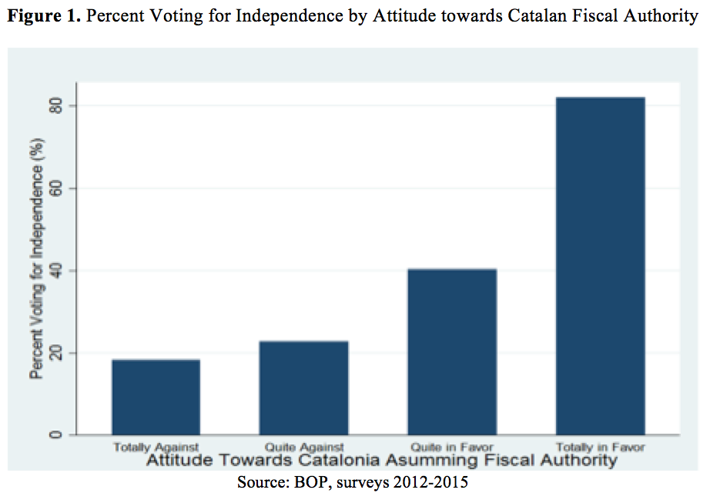
The response options are: 1) Totally in favor, 2) Quite in favor, 3) Quite against, and 4) Totally against. A dummy variable was created for each of these responses. According to Table 1, only 7.4% of respondents are totally against Catalonia assuming fiscal policymaking control, while 60.3% are totally in favor. In accordance with the theoretical framework, favorability towards Catalonia assuming fiscal policymaking control should have a positive relationship with the dependent variable: the stronger the desire for Catalonia to obtain fiscal autonomy, the stronger the desire to secede as witnessed by the strong correlation in Figure 1. It should be noted that a positive relationship can only give evidence for obtaining fiscal policymaking autonomy being a sufficient, not necessary, condition for desiring independence.
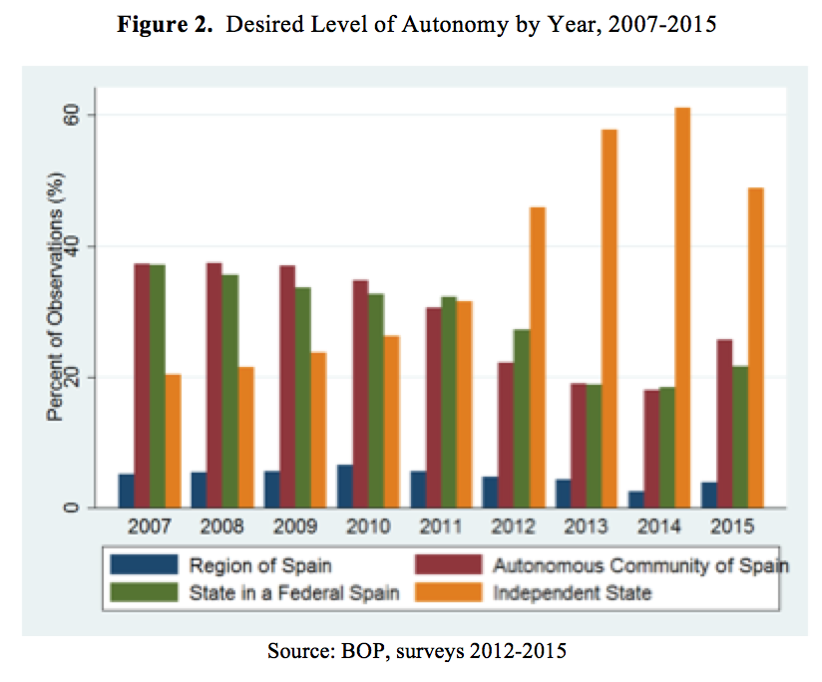
The model controls for a wide variety of other factors, including cultural, economic, political, educational, and demographic characteristics. The average age in the sample is 47.5 years old (range 18 to 99). Younger individuals tend to support independence more than older individuals—there is a greater resistance to change the older one gets, and youth (under 30 years of age) unemployment is greater than average unemployment. 49.3% of the respondents are female. Approximately 90% of the sample had at least completed compulsory education with 27.6% having completed university. Education was separated out into four dummy variables: less than compulsory education, compulsory education, vocational or pre-university education, and university. Furthermore, there is a control for the survey rounds themselves to see if support for secession changes significantly over time. Given the rejection of the 2006 Statute of Autonomy in 2010 and the global financial crises of 2008-09, it is likely that there was an increase in support for secession during those tough political and financial times as evidenced by the increasing support for independence over other levels of autonomy following 2008 in Figure 2.

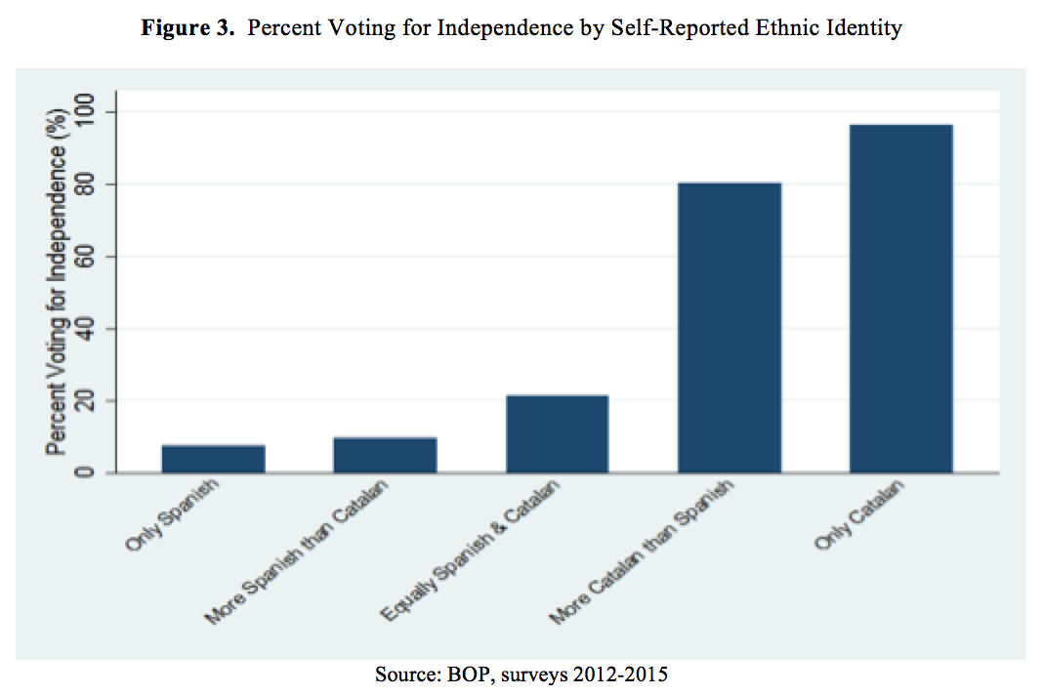
Ethnic identity is a huge influence in shaping the character of a push for secession. According to the literature, a region’s separatism is strongest when the region has a unique ethnic character and is economically fitter than the country as a whole. Catalonia is a region that has its own culture and traditions, language, and history.
I control for the extent to which respondents identify as Catalan. The survey question reads as follows: “With which of the following sentences do you feel more identified? I feel...” Respondents answered: only Spanish (4.2%), more Spanish than Catalan (3.9%), equally Spanish and Catalan (36.9%), more Catalan (29.3%), and only Catalan (25.8%). This allows participants to determine for themselves what it means to be Catalan. A stronger identification with being Catalan should be positively associated with support for secession; as Figure 3 demonstrates there is a strong correlation between self-reported Catalan identity and pro-independence voting.
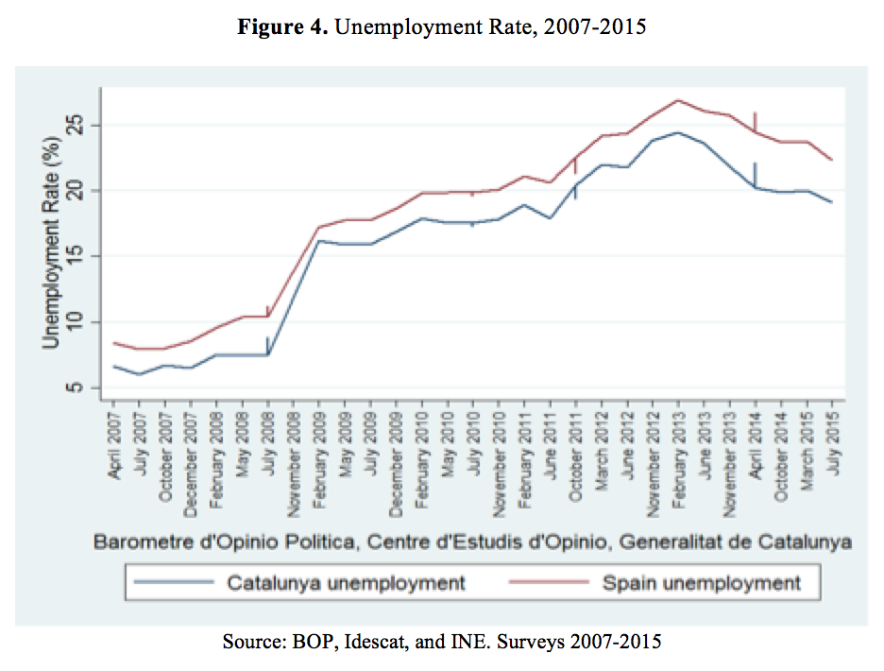
I control for the actual economic situation of Catalonia versus Spain by including quarterly, seasonally adjusted interannual variation in GDP (base year 2010) measured in percent in volume and unemployment rate for both Catalonia and aggregate Spain. As shown in Figure 4, both Catalan and Spanish unemployment rose steeply in 2008 and have still not stabilized to pre-financial crisis levels. I also include individual employment status, as it is a question asked on the survey, as a dummy variable that equals 1 if employed and 0 otherwise. Being employed should have a negative association with desire to secede.
Dissatisfaction with the national political environment can have a profound effect on a Catalonians desire to secede. Secession is usually an option of last resort, an alternative considered only when all other options working within the current system have been eliminated. Given that in reviewing Catalonia’s proposed new Statute of Autonomy in 2006, the Spanish Constitutional Court identified parts as being unconstitutional, Catalonians may feel that they have reached an impasse in negotiation with the central government. To control for the perception of national politics, I use a survey question that requires the participant to assess the political situation in Spain on a scale of 1 (very good) to 5 (very bad) and turn each response into a dummy variable. A negative assessment of the political situation of Spain should have a positive relationship with desire to secede.
VII. Estimation Strategy
An OLS regression will estimate the relationship between desire to secede amongst Catalan citizens and variables of interest, in particular perception of Catalonia as the stronger economy compared to Spain and desire for Catalonia to hold fiscal authority. The dependent variables (Y_{t}) in this study are alternate ways to conceptualize ‘desire to secede’: favoring independence as the preferred level of autonomy for Catalonia (model 1-2), and voting for independence in the eventuality of a regional referendum (model 3-4).
Y_{t} = $β$₀ + $β$₁CEPS + $β$₂₋₄ FP + $β$₅₋₈CVS + $β$₉CGDP + $β$₁₀CE + $β$₁₁SGDP + $β$₁₂SE + $β$₁₃RE +
$β$₁₄₋₁₇SPS + $β$₁₉₋₂₁EDUC + $β$₂₂FEMALE + $β$₂₃AGE + $β$₂₄AGE² + $β$₂₄SR + $ε$_{i}
There are two primary independent variables of interest. The first is a dichotomous variable, CEPS, that equals 1 if the Catalan economy is perceived as stronger than Spain’s and 0 otherwise. The second, FP, is a vector of dummy variables assessing the respondent’s attitude for Catalonia assuming fiscal policymaking control, which is applied on a subsample (models 2 and 4) due to the corresponding survey question being asked intermittently. The dummies are: Quite Against, Quite in Favor, and Totally in Favor and Totally Against is the omitted category. CVS is a vector of dummy variables describing the degree to which the respondent identifies as Catalan versus Spanish: Only Spanish (omitted), More Spanish than Catalan, Equally Spanish and Catalan, More Catalan than Spanish, and Only Catalan. CGDP and CE represent the quarterly percent variation in Catalonian GDP and Catalonian unemployment rate respectively. SGDP and SE represent the quarterly percent variation in Spanish aggregate GDP and Spanish unemployment rate respectively. RE is the respondent’s personal employment status, equaling 1 if employed and zero otherwise. SPS is a vector of binary variables assessing the respondent’s evaluation of Spain’s national political situation, with five categories: Very Good, Good (omitted), Neither Good nor Bad, Bad, and Very Bad. Good is omitted in place of Very Good due to less than 1% of the sample selecting the response Very Good. EDUC is a vector of binary variables accounting for the respondent’s education level, with categories: Less than Compulsory Education (omitted), Compulsory Education, Vocational or Pre-University, and University. FEMALE is a dichotomous variable equaling 1 if the respondent is female and zero if male. AGE is a linear continuous variable accounting for the respondent’s age in years; AGE² is included due to an expected non-linear relationship between age and desire for independence. SR is continuous variable representing the survey round, a proxy for time, and $ε$ is the error term.
VIII. Results and Discussion
Table 2 presents the results of the empirical models estimating the desire of Catalans to become independent. Models 1 and 2 have the dependent variable of desire for independence over other levels of self-governance, and Models 3 and 4 have the dependent variable of referendum vote for independence. Models 2 and 4 include an additional control variable, ‘attitude towards Catalonia assuming fiscal policymaking control’, which was only available for some of the survey rounds observed resulting in a smaller sample size.
The results presented in Table 2 show that after controlling for a range of factors known to encourage support for secession, perceiving the Catalan economy as being stronger than Spain’s is positively and significantly associated with both favoring independence and voting for independence. Respondents who perceive the Catalan economy to be stronger have a 1.4 percentage point higher probability of preferring independence over those who perceive the Catalan economic situation to be equal to or worse off than Spain’s. This probability doubles when evaluating pro-independence voting in a referendum. Intuition suggests that this sharp increase in strength of effect may be the result of ‘protest’ voting—a vote cast to demonstrate the voter’s dissatisfaction with the status quo, not necessarily a vote truly in favor of independence.
Table 2. Results of OLS Regression Models
 | Favors Independence |  | Referendum Vote is Pro-Independence
 | OLS (1) | OLS (2) | OLS (3) | OLS (4)
Catalan Economy Perceived as Stronger than Spain's | 0.017***  (0.004) | 0.014**  (0.006) | 0.047***  (0.005) | 0.031***  (0.005)
Attitude towards Catalonia Assuming Fiscal Policymaking Control (Omitted: Totally Against)
Quite Against |  | -0.016  (0.014) |  | 0.005  (0.013)
Quite in Favor |  | -0.023*  (0.013) |  | 0.067***  (0.011)
Totally in Favor |  | 0.117***  (0.012) |  | 0.251***  (0.011)
Degree to which Respondent Identifies as Catalan vs. Spanish (Omitted: Only Spanish)
More Spanish than Catalan | 0.009  (0.011) | 0.006  (0.023) | 0.017  (0.018) | 0.018  (0.021)
Equally Spanish and Catalan | 0.040***  (0.008) | 0.025  (0.017) | 0.134***  (0.013) | 0.083***  (0.015)
More Catalan than Spanish | 0.323***  (0.008) | 0.383***  (0.017) | 0.709***  (0.013) | 0.584***  (0.016)
Only Catalan | 0.702***  (0.009) | 0.703***  (0.018) | 0.859***  (0.013) | 0.699***  (0.016)
Catalonia GDP Variation (%) | 0.008***  (0.003) | 0.032***  (0.009) | 0.001  (0.008) | -0.001  (0.008)
Catalonia Unemployment (%) | -0.025***  (0.004) | -0.001  (0.013) | -0.051***  (0.008) | 0.021*  (0.012)
Spain GDP Variation (%) | -0.008**  (0.004) | -0.029**  (0.014) | -0.022**  (0.010) | -0.005  (0.013)
Spain Unemployment (%) | 0.024***  (0.005) | 0.011  (0.014) | 0.049***  (0.006) | -0.036***  (0.012)
Respondent is Employed | -0.001  (0.004) | -0.002  (0.007) | 0.003  (0.006) | -0.006  (0.006)
Spain's Political Situation (Omitted: Good)
Very Good | 0.060***  (0.023) | 0.100*  (0.058) | 0.050  (0.047) | 0.079  (0.053)
Neither Good nor Bad | 0.005  (0.007) | -0.012  (0.023) | -0.013  (0.017) | -0.013  (0.020)
Bad | 0.018***  (0.005) | 0.002  (0.015) | 0.019  (0.012) | 0.016  (0.014)
Very Bad | 0.070***  (0.006) | 0.033**  (0.015) | 0.054***  (0.012) | 0.037***  (0.014)
Respondent's Education Level (Omitted: Less than Compulsory Education)
Compulsory Education | -0.000  (0.006) | -0.014  (0.012) | 0.022**  (0.009) | -0.001  (0.011)
Vocational or Pre-University | -0.042***  (0.007) | -0.044***  (0.013) | 0.018*  (0.009) | -0.013  (0.011)
University | -0.060***  (0.007) | -0.072***  (0.013) | 0.023**  (0.010) | -0.022*  (0.012)
Survey Round | 0.009***  (0.001) | 0.019***  (0.006) | 0.007*  (0.004) | 0.026***  (0.006)
Female | 0.009***  (0.003) | 0.026***  (0.006) | -0.013***  (0.005) | 0.002  (0.005)
Age | -0.004***  (0.001) | -0.006***  (0.001) | -0.000  (0.000) | -0.003***  (0.001)
Age² | 0.000***  (0.000) | 0.000***  (0.000) | 0.000  (0.000) | 0.000**  (0.000)
Observations | 51,273 | 16,234 | 21,182 | 16,234
R-squared | 0.406 | 0.464 | 0.518 | 0.538
Standard errors in parentheses: ***p<0.01, **p<0.05, *p<0.1
Source: BOP, Idescat, and INE. Referendum vote was not measured prior to 2012 and Fiscal policy attitude was measured intermittently resulting in reduced sample sizes for models 2-4
Strong support for Catalonia’s government to assume fiscal policymaking control is found to be positively and significantly associated with preference for independence and voting for independence in a referendum. Respondents who are totally in favor of Catalonia assuming fiscal policymaking control have an 11.7 and 25.1 percentage point higher probability of favoring independence and voting for independence, respectively, than those respondents who are totally against Catalan fiscal autonomy. Catalan independence seems to be a function of criticisms over fiscal policy, with the conceptual understanding that Catalonia wants to assume fiscal policymaking control in order to avoid subsidizing disadvantaged regions in the country and retain its own wealth.
Models 2 and 4, which control for all variables (including attitude towards fiscal policy), were found to be the strongest as indicated by their stronger R² values; Model 2 explains 46.4 percent of the variability of the response data and Model 4 explains 53.8 percent. Four of the control variables were found to be consistent predictors across these two regressions. First, stronger identification as Catalan (versus Spanish) is positively, and significantly associated with independence desires. Self-identifying as more Catalan than Spanish and only Catalan produces a 38.3 and 70.3 percentage point higher probability, respectively, of desiring independence (Model 2). These probabilities shift to 58.4 and 69.9 percentage points, respectively, when considering referendum voting (Model 4). Participants who identify more with being Catalan are more likely to support independence.
Second, negative feelings towards the current political situation of Spain are associated with stronger support for independence. Respondents who evaluated Spain’s political situation as very bad had a 3.3 and 3.7 percentage point higher probability of desiring and voting for independence, respectively, than those who evaluated Spain’s political situation as good. Increased frustration with Spain’s political environment heightens secessionist desires.
Third, time is positively and significantly associated with stronger secessionism. Moving from one survey round to the next round, the probability of desiring independence increased by 1.9 percentage points. The probability of voting for independence grew by 2.6 percentage points each survey round. Fourth, age is found to be negatively and significantly associated with desired independence. A one year increase in age will decrease the probability of desiring and voting for independence by 0.6 and 0.3 percentage points respectively. As respondents become older the effect of age becomes less. Older participants are less likely to support independence than younger ones.
Other control variables were not consistent predictors of secessionist desire. A one percent increase in the percent variation of Catalan GDP increased preference for independence by 3.2 percentage points, but did not have a significant influence on referendum voting. Conversely, a one percent increase in the rate of unemployment in aggregate Spain decreased pro-independence voting by 3.6 percentage points. This supports the claim that Catalans endorse secessionism due to perceived unfair redistribution of wealth (biased fiscal structures), and not because of a desire to distance themselves from national economic problems. Education level is highly significant for predicting support for independence, but not for predicting a vote for independence in a referendum. Participants with a higher education level are less likely to favor independence. Being female was a consistent predictor of preference for independence, but was not significant in predicting the probability of voting for independence.
IX. Conclusion—Implications: Breakup or Unity Scenarios
The current status quo is not working in Spain. Results show that viewing Catalonia as the stronger economy relative to Spain and desire for Catalonia to assume fiscal policymaking control are significant contributing factors to desired independence. Respondents who perceive the Catalan economy to be stronger have an almost 2 percentage point higher probability of preferring independence over those who perceive the Catalan economic situation to be equal to or worse off than Spain’s. This probability doubles when evaluating pro-independence voting in a referendum. Respondents who are completely in favor of Catalonia assuming fiscal policymaking control have even higher probabilities of favoring independence as the preferred level of Catalan self-governance (11.3 percentage points) and voting for independence in a referendum (24.9 percentage points) than those respondents who are totally against Catalan fiscal autonomy. This is in addition to other compelling factors such as self-identification as more Catalan than Spanish, dissatisfaction with Spanish national politics, and more and more time passing with no compromise being reached. A united Spain is only feasible under two scenarios: a reform of the Constitution along federal lines or a ‘special deal’ for Catalonia. The failure of the central government to approve or consider a new Statute of Autonomy for Catalonia is a driving factor for current pro-secession sentiment. Spanish national sentiment is pushing for a power shift back to the Spanish state, while Catalonia is in favor of the direct opposite.
A federalist reform would hypothetically resolve the majority of these tensions. This solution would involve 1) increased fiscal responsibility under which regional government would be funded by taxes levied and collected by these governments and not by grants afforded by the central government, 2) changed equalization schemes that rectify horizontal and vertical fiscal imbalances by matching expenditure needs with potential tax resources, and 3) increased regional input in statewide decision making (Castells 2014). A ‘special deal’ for Catalonia would likely have the same demands without calling for nationwide reform. It would be a deal similar to that already achieved by the Basque Country and Navarre.
Secession, while eliminating the negative fiscal flows problem and granting full fiscal and political autonomy, has the consequences of a potential decline of sales to the Spanish market, allocation of a share of Spanish debt, and a potential exit from the EU and/or Eurozone (Castells 2014). The Spanish market is the main customer for Catalan exports, and the border effect resulting from independence can significantly dampen trade. However, Ghemawat, Llana, and Requena (2010) found that while Catalonia trades much more with the rest of Spain than the rest of the world, there also has been a slow but steady increase in its openness ratio to foreign markets. The comparative importance of international trade has increased since the mid-1990s, and that of interregional trade has lessened. Catalonia exports much more to the rest of Spain than it imports: it is the international import hub for the rest of Spain. Relative to other Spanish regions, Catalonia leads in both international and interregional trade volumes. The border effect caused by seceding is suggested to be a substantial 9% in Catalan GDP (Bell 2014), but, relative to the rest of Spain, Catalonia is in a much better position to transition into an independent nation based on trade flows. On the other hand, EU and EZ membership is a deciding factor for secession; costs of abandoning the Euro and exiting the simplified trade flows within the EU would be astronomical and, probably, conclusive in deciding the vote.
It is evident that some kind of change is anticipated in Spain, though the exact course of that change is uncertain. Currently, no form of dialogue exists between the central government and Catalonia and the matter at stake is a referendum about independence and not seceding itself. The central government is overruling any calls for compromise operating under the false belief that it can stamp out divergent thinking through sheer obstinacy. Without willing synergy from either side, Spain faces a compromising stalemate in which the needs of people on either side of the debate cannot and will not be satisfied in an agreeable manner.

X. Bibliography
Bell, D. N. (2014). Scotland and small country independence: The assessment. Oxford Review of
Economic Policy, 30(2), 189-207.
Boylan, B. M. (2015). In pursuit of independence: The political economy of Catalonia's
secessionist movement. Nations and Nationalism, 21(4), 761-785.
Castells, A. (2014). Catalonia and Spain at the crossroads: Financial and economic aspects.
Oxford Review of Economic Policy, 30(2), 277-296.
Correa-López, M., & Mingorance-Arnáiz, A. (2012). Demografía, mercado de trabajo y
tecnología: El patrón de crecimiento de Cataluña, 1970- 2020. Estudios De Economía
Aplicada, 30(1), 1-34.
Ghemawat, P., Llano, C., & Requena, F. (2010). Competitiveness and interregional as well as
international trade: The case of Catalonia. International Journal of Industrial
Organization, 28(4), 415-422.
López-Casasnovas, G., & Rosselló-Villalonga, J. (2014). Fiscal imbalances in asymmetric
federal regimes. The case of Spain. Review of Public Economics, (209), 55-97.
Peña Sánchez, A. R. (2010). Contribución de la cultura al crecimiento de la economía regional
española. Cuadernos De Economía, 29(53), 211-238.
Pérez, ,F.Javier Escrib, & García, M. J. M. (2013). Productividad y empleo regional en España:
Un enfoque dinámico. Investigaciones Regionales, (27), 65-89.
Sambanis, N., & Milanovic, B. (2014). Explaining Regional Autonomy Differences in
Decentralized Countries. Comparative Political Studies, 47(13), 1830-1855.
Sorens, J. (2005). The cross-sectional determinants of secessionism in advanced democracies.
Comparative Political Studies, 38(3), 304-326.

